Test Report

* A test report is an organized summary of testing objectives, activities, and results.
* It is created and used to help stakeholders (product manager, analysts, testing team, and developers) understand product quality and decide whether a product, feature, or a defect resolution is on track for release.
* Test report is an assessment of how well the Testingis performed
* Based on the test report, stakeholders can evaluate the quality of the tested product and make a decision on the software release.
* For example, if the test report informs that there are many defects remaining in the product, stakeholders can delay the release until all the defects are fixed.

### **Basic Test Report Summary**

A very basic test report for a small application or organizations should include, at a minimum, the following:

* Project Information — Information about the project.
* Test Objective — Information about test type and purpose.
* Test Summary — Defining passed, failed, and blocked test cases.
* Defects — Described with priority and status.

## 

## 

## 

## 

## **What does a test report contain?**

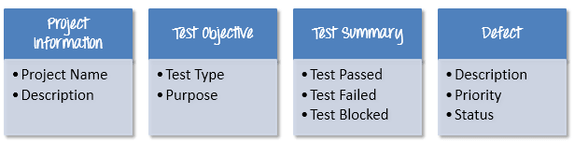

### **Project Information**

All information of the project such as the project name, product name, and version should be described in the test report. For example, the information of Guru99 Bank project will be as follows

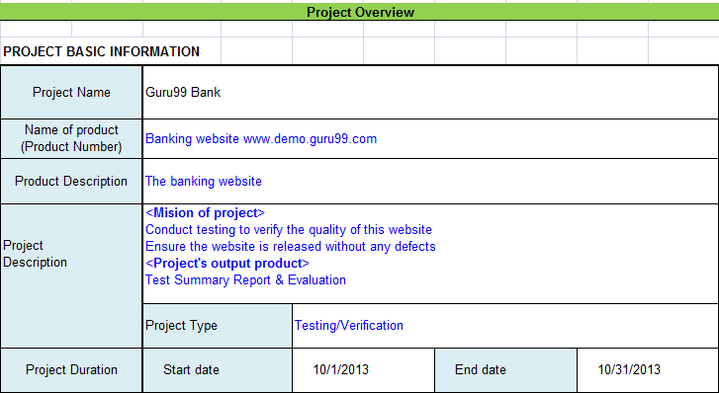

**Test Objectives:**

Test Report should include the objective of each round of testing, such as Unit Test, Performance Test, System Test …Etc.

### **Test Summary**

This section includes the summary of testing activity in general. Information detailed here includes

* The number of test cases executed
* The numbers of test cases pass
* The numbers of test cases fail
* Pass percentage
* Fail percentage
* Comments

### **Defect**

One of the most important information in the Test Report is defect. The report should contain following information

* Total number of bugs
* Status of bugs (open, closed, responding)
* Number of bugs open, resolved, closed
* Breakdown by severity and priority

**Benefits of writing test reports**

* Offers information about the various activities performed during the testing process.
* Determines whether product is ready for release
* The current status of the project and likewise the quality of the product are informed.
* Summarizes the results of all testing efforts.
* validate the quality delivered by your supplier.
* Communicates system quality and testing status
* Types of making test report:

Team and individual

Daily or final

The typical benefits of a test report include:

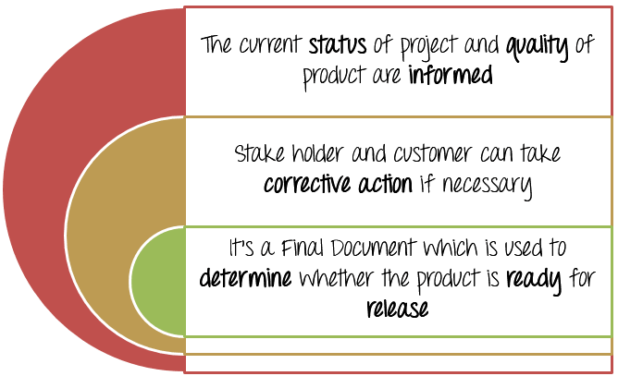

**Who prepares?**

* Prepared by the test leads or test managers.
* Test managers prepare this document at the end of the testing project.

**Test Report Template:**

